**SPRINT - 1**

|  |  |
| --- | --- |
| Date | 18 Nov 2022 |
| Team ID | PNT2022TMID07381 |
| Project Name | Personal Assistance for Seniors Who Are SelfReliant. |

1. Creating IBM Watson IOT Platform and device:

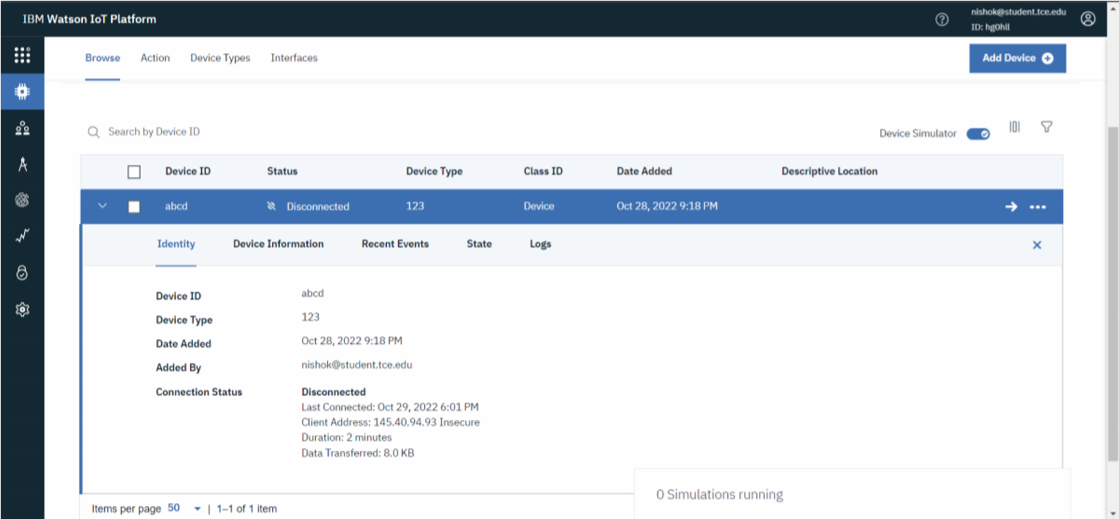

1. Creating Node-RED Service:

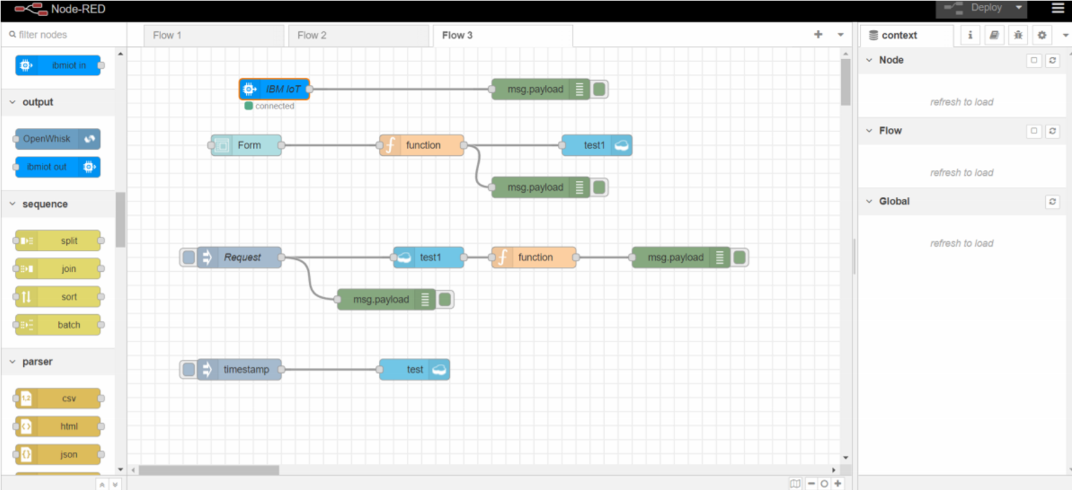

1. Creating Text to Speech Service:

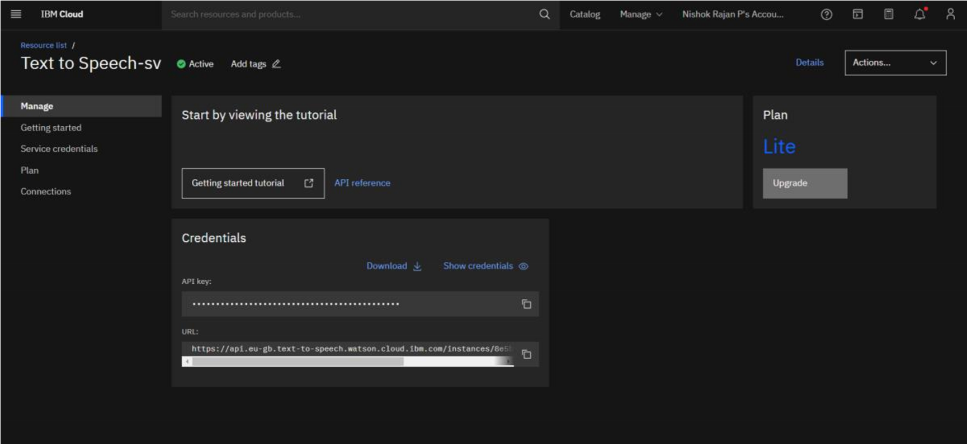4. Creating a Database in Cloudant DB:

